**ENTRANCE**

**Entrance Procession** ♪Jesu,Toy of Man’s Desiring(J.S.Bach)

Groom Parents & Bridal party

**Bride & Groom Entrance** 　 (*Stand up please*)

♪Canon In D Major(J.Pachelbel)

**＋Entrance Rite Opening** Prayer Priest

**♪GLORIA♪**

**LITURGY OF THE WORD**

(*Please have a seat*)

**＋First Reading** --------------------Sirach 26:1-4, 13-16

　　Read by Groom brother　 Paolo ○○○○○

　　　　　　　　　　　　　　*

Blessed the husband of a good wife,twice-lengthened are his days; A worthy wife brings joy to her husband,peaceful and full is his life.A good wife is a generous gift bestowed upon him who fears the Lord; Be he rich or poor, his heart is content,and a smile is ever on his face. A gracious wife delights her husband,her thoughtfulness puts flesh on his bones; A gift from the Lord is her governed speech,and her firm virtue is of surpassing worth. Choicest of blessings is a modest wife,priceless her chaste soul. A holy and decent woman adds grace upon grace;indeed, no price is worthy of her temperate soul. Like the sun rising in the Lord’s heavens,the beauty of a virtuous wife is the radiance of her home.

**The word of the Lord.**

**1**

**＋RESPONSORIAL PSALM**

♪Psalm 103 The Lord is Kind and Merciful

*(Please everyone sing together)*

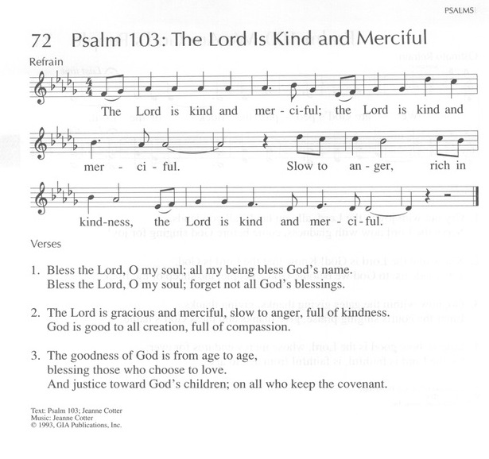

**THE WEDDING CEREMONY**